AP CSP Python with Robots  Mission 4 Obj 8-12 Assignment |  | Name:
Mission 4 Introduction
Read the introduction and project goals. During this assignment, you will complete the last three goals.
Mission 4 Objectives 8-12
Take the quiz.
How did you do? Is there anything you need to practice or review?
Complete Objective 8. Use functions for this objective by making these changes:
This objective has the ‘bot moving forward and then spinning. You already coded this with functions in NavSquare_functions. Define a function for go_straight() and a function for spin(), which is just like the turn_90() function. Then call the functions in the main program (but not the while loop). Remember to enable the motors!
Test your code until you meet the requirements of moving forward 3 feet and spinning 360 degrees. Your goals will not be validated even though the code works great. You will need to add a few lines of code to the end of your program to meet the goals. Then you can delete the lines of code and move forward. Add this to the end of your program AFTER you get the moving forward and spinning correct:
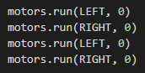
Complete Objective 9. Use the suggestion to start a new file for testing the code: test_code
What is the purpose of the outer loop?
Complete Objective 10. Finish trying the code in test_code. After adjusting the condition to make the cute beeps last long enough for the spin, you will add the code into SweepLEDs.
Use another function for this objective by making these changes:
1. Add from random import randrange (near top of the code)
2. In SweepLEDs, define another function for cute_beeps(). Copy and paste your code for the cute beeps into the function.
3. Add global count to the cute_beeps() function, indented just below the definition.
4. Modify spin() by deleting the sleep() command and calling cute_beeps() instead. Test and debug your code until it is working correctly.
5. You will need to make one change to validate the last goal. Add count = 0 just below motors.enable(True). All goals should be validated and you have a nice robot animation.
Complete Objective 11. Use test_code for this objective. Delete the code already there, and type the code for the function and note.
Complete Objective 12. Follow the instructions below.
Copy and paste the note() function into SweepLEDs in the section with all the functions.
Define the variables F4 and C5 near the top with the other variables.
Call the note() function at the bottom of the main program, as instructed by CodeTrek.
Your main program may look similar to this:
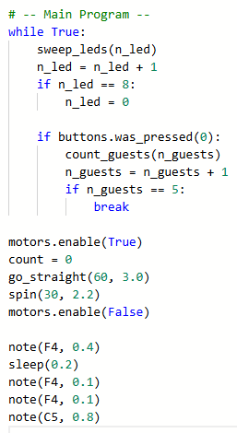
After Objective 12, submit your completed SweepLEDs program to the teacher.

